**Pizza Sales Project SQL Output**

1. **KPI’S**

**1.TOTAL REVENUE**

SELECT SUM(total_price) as Total_Revenue from pizza_data

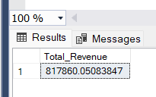

1. **Average Order Value**

select SUM(total_price)/ COUNT(DISTINCT order_id) AS Avg_Order_Value from pizza_data

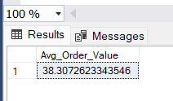

1. **Total Pizza Sold**

select SUM(quantity) as Total_Pizza_Sold from pizza_data

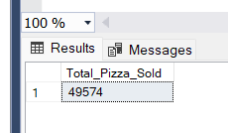

1. **Total Order**

select COUNT(Distinct order_id) from pizza_data

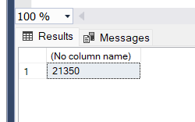

5.**Average Pizza per-order**

select CAST(Cast(SUM(quantity) as decimal(10,2))/

cast(COUNT(distinct order_id) as decimal(10,2)) as decimal(10,2)) as AVG_PIZZA_ORDER from pizza_data

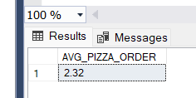

Chart requirement

1. Daily trend for total order

select DATENAME(DW, order_date) as order_day, COUNT(DISTINCT order_id) AS Total_orders

from pizza_data

group by DATENAME(DW, order_date)

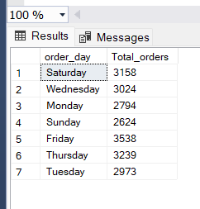

1. Monthly trend of total order

select DATENAME(MONTH, order_date) as Month_Name, COUNT(DISTINCT order_id) AS Total_orders

from pizza_data

group by DATENAME(MONTH, order_date)

order by Total_orders desc

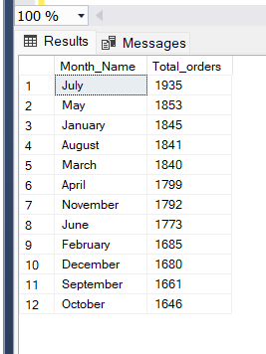

3.% of sales by pizza category

select pizza_category, SUM(total_price) as total_sales, SUM(total_price)*100/

(select sum(total_price) from pizza_data where MONTH(order_date) =1 ) as PCT

From pizza_data

where MONTH(order_date)=1

group by pizza_category

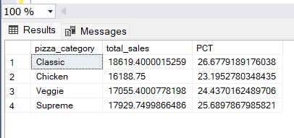

4.% of sale by pizza size for jan

select pizza_size,cast( SUM(total_price) AS decimal(10,2)) total_sales,

cast( SUM(total_price)*100 / (select sum(total_price) from pizza_data where DATEPART(QUARTER,order_date)=1 ) AS decimal(10,2)) as PCT

From pizza_data

where DATEPART(QUARTER,order_date)=1

group by pizza_size

order by PCT DESC

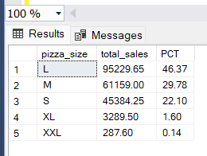

5.top 5 best sellers by revenue

select Top 5 pizza_name, cast(SUM(total_price) as decimal(10,2)) as Total_Revenue from pizza_data

group by pizza_name

order by Total_Revenue desc

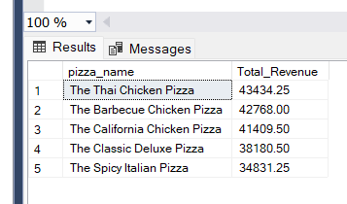

1. Bottom 5 selling pizza by revenue

select Top 5 pizza_name, cast(SUM(total_price) as decimal(10,2)) as Total_Revenue from pizza_data

group by pizza_name

order by Total_Revenue ASC

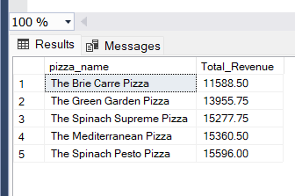

1. Top 5 with respect to quantity

select Top 5 pizza_name, cast(SUM(quantity) as decimal(10,2)) as Total_Quantity from pizza_data

group by pizza_name

order by Total_Quantity DESC

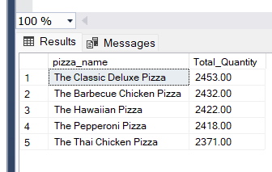

1. Bottom 5 with respect to quantity

select Top 5 pizza_name, cast(SUM(quantity) as decimal(10,2)) as Total_Quantity from pizza_data

group by pizza_name

order by Total_Quantity

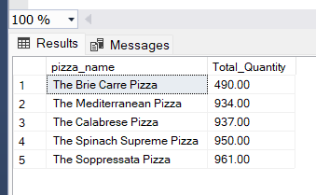

1. Top 5 with respect to order

select Top 5 pizza_name, COUNT(distinct order_id) as Total_Orders from pizza_data

group by pizza_name

order by Total_Orders DESC

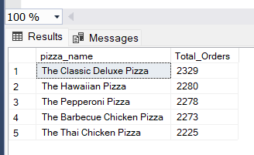

1. Bottom 5 with respect to order

select Top 5 pizza_name, COUNT(distinct order_id) as Total_Orders from pizza_data

group by pizza_name

order by Total_Orders

